# Animal Shelter Search README

**About the Project/Project Title**

This module is part of the greater **Animal Shelter Search Application**. This specific dashboard module serves as front-end application layer between the on top of the middle-ware and the database. It was designed to provide an interface to quickly find dogs in animal shelters that are most suitable for various rescue operations.

## Getting Started

Download the aac_api.py and aac_api_test.ipynb files. Database connection details are configured in aac_api.py. Load aac_api_test.ipynb into Jupyter Notebook and run the cells to execute tests.

Then run ProjectTwoDashboard 2.ipynb in Jupiter Notebook to start the front-end application.

## Installation

Requires Jupyter Notebook and python3.

## Usage

Application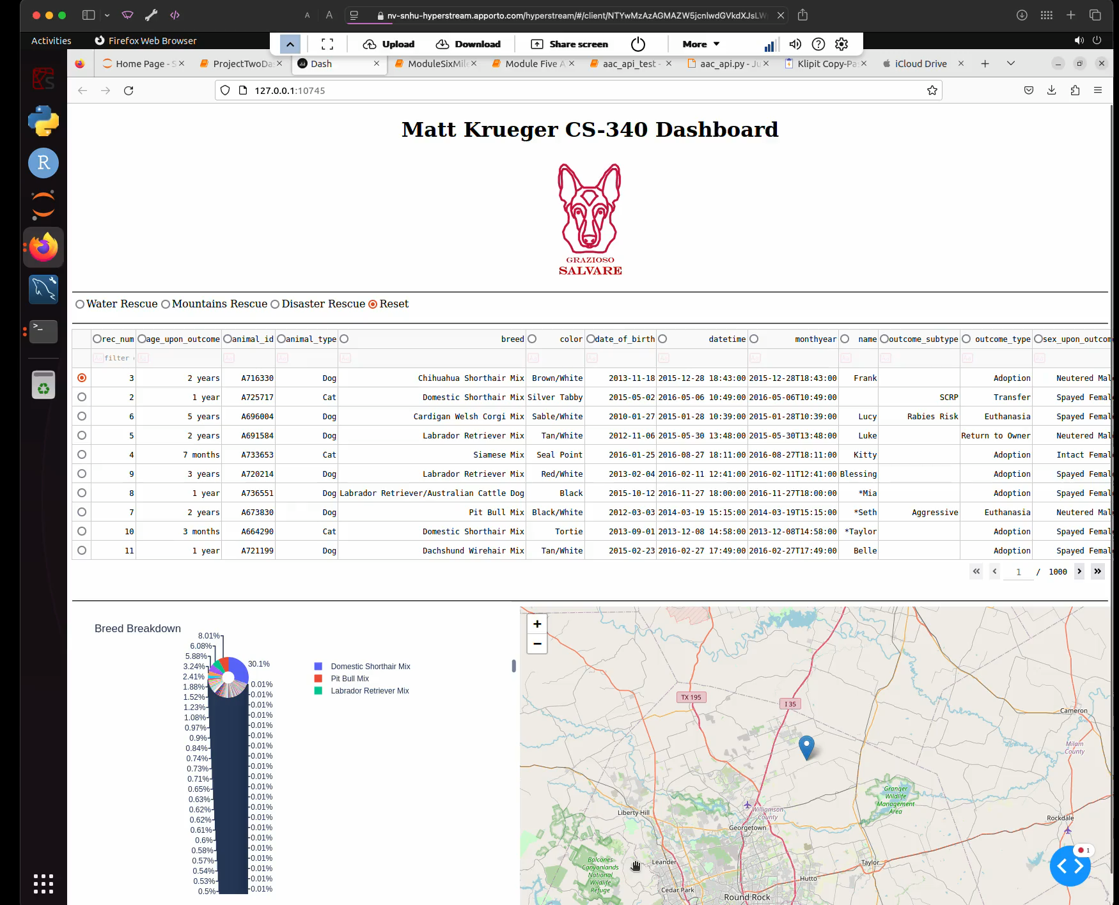

Test Execution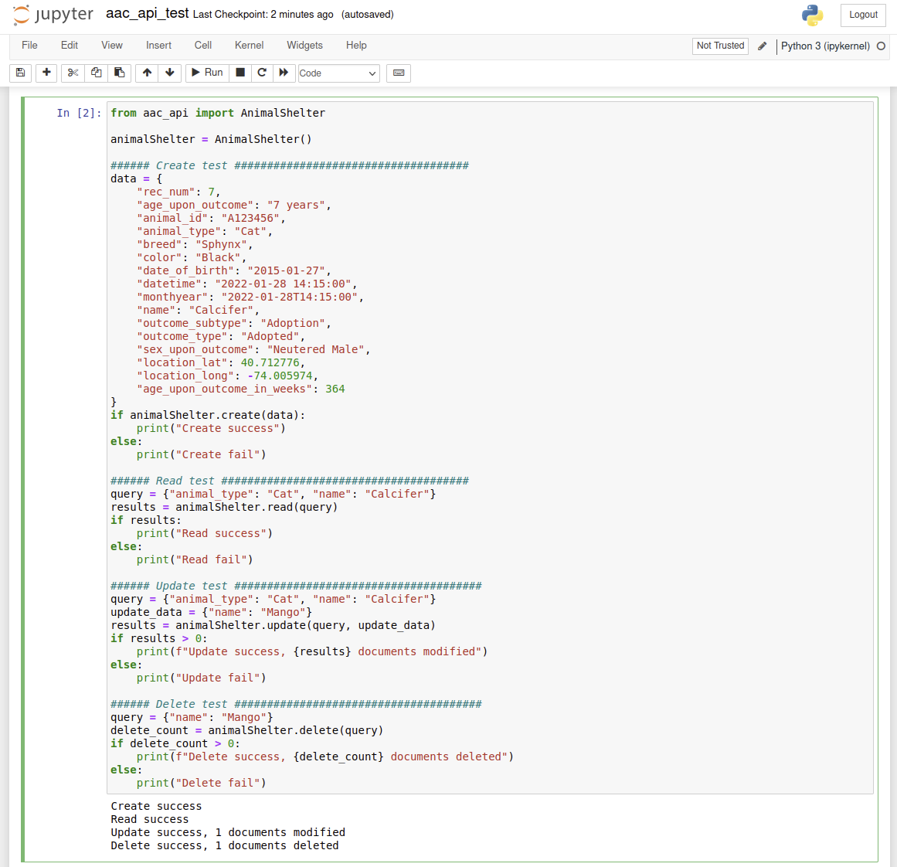

## Technologies Used

* MongoDB - For flexible schema storage of many different pet types. This was used for the model layer. It interfaces through python using the the native mongodb python connector. The JSON like objects map well with the languages dictionary type data structures.
* Dash - For rapid front end development in python, keeping the same language through the different application layers.

## *C*ontact

Matt Krueger